Assignment-31 July

Questions:-

Assignment1 : Write a query to display the employees whose firstname starts with 'Y' and ends with 'n' from employees table

Assignment2 : Write a query to display the emp_no and salary increased by 30% from salaries table.

Assignment3 : Write a query to display unique titles from titles table.

1. SELECT * FROM employees WHERE first_name LIKE 'Y%n';

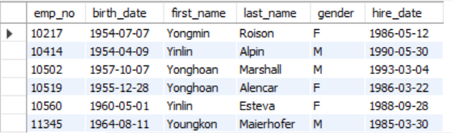

1. SELECT emp_no, salary * 1.30 AS increased_salary FROM salaries;

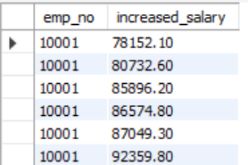

1. SELECT DISTINCT title FROM titles;

